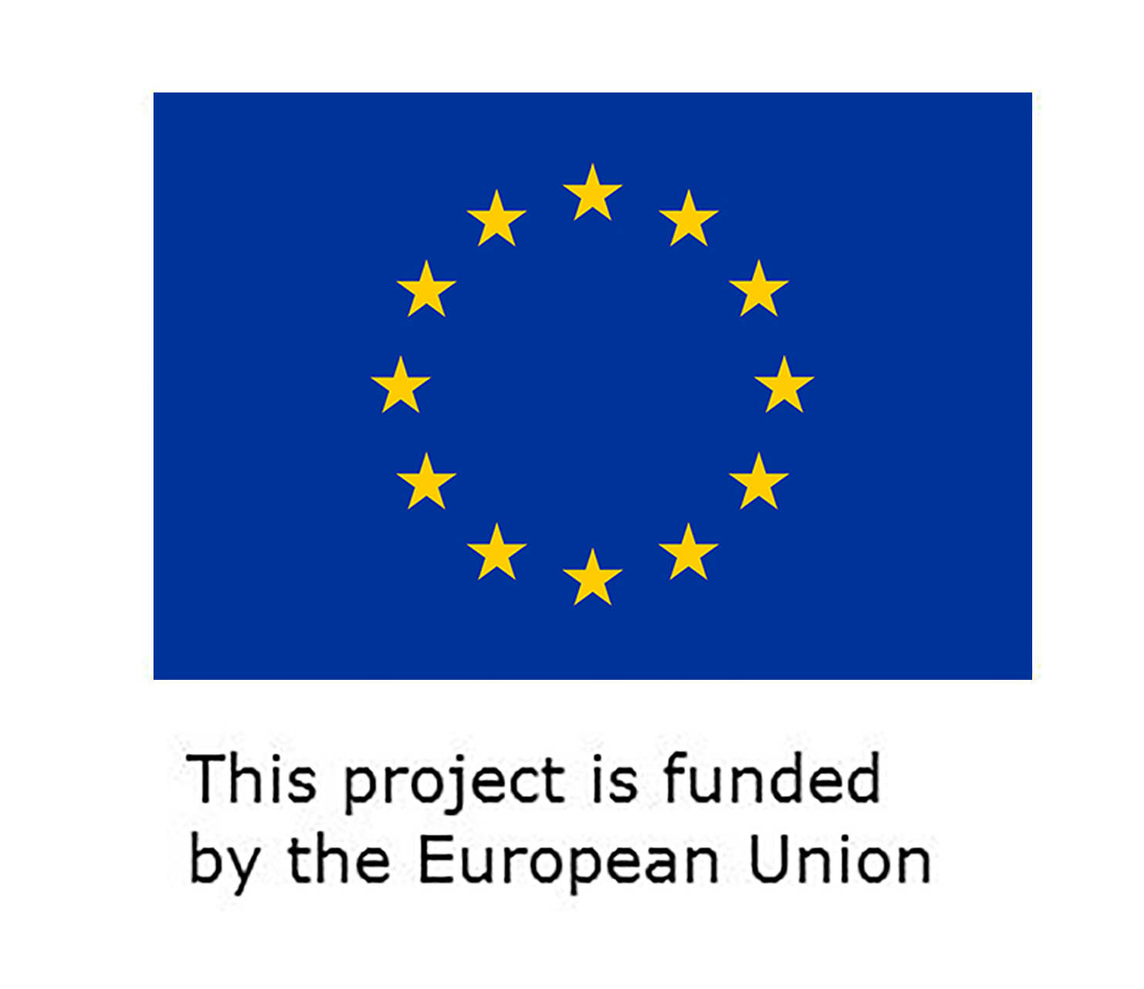
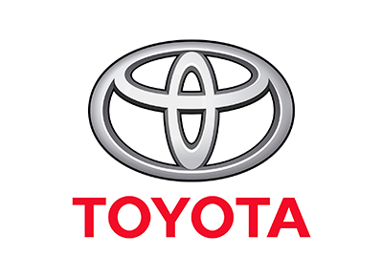


Technical Course
Vocational training Application Form

1. Details of the applicant
(Please provide your details in the below form. You may add additional rows if deemed required)

Full Name

Age

Gender

Fluency in Arabic & English
Education Level (including year of graduation)

Contact details  Address: | Email:  Mobile:
Confirmation of availability to attend the course for Twelve weeks
(From 04.09.2022 to 24.11.2022)
Certificates, recommendation and reference letters

If you are an internally displaced person, please elaborate in more details

Please add any other relevant information

2. Recommendation and/or Reference letters
Please briefly describe why you are interested to attend this training programme in no more than 400 words.
You may consider the following queries:
• Why would you like to attend the training programme?
• How is the programme related to your career and educational background?
• Will this program help you to start your own private business?
• Have you worked in on car maintenance before?
• Have you taken any courses in this field before?
• If this is first time .... Do you have the desire to learn about this field and work in it?
Please submit your entries in writing to: mahmoud.ghmim@toyota.ly
Deadline for submission is: 31 August 2022.

